Student’s name | …………………………………………………….…… | Grade | 6
Subject | Computer | Week No. | 6
Lesson Title |  | Unit
Midterm Exam Worksheet

Question A: Fill in the blanks.
- The ____________ tool removes the overlaying shape from the parent shape.
- The ___________ tool adds/merges the selected shapes to create a single shape.
- Holding the ______________ key allows us to select multiple shapes
- The size, position and orientation (angle of rotation) can be set in the dimension parameters of the __________ panel.
- The dimensions of an A4 size paper are______________
- The ___________ option is used to remove the overlaying shape.
- _________ allows us to set parameters for text, changing its appearance.

Question B: State whether the statements are True/False.
- The unite tool removes the overlaying shape from the parent shape.
_____________
- The toolbar consists of tools that are used to create an artwork.
______________
- We hold the shift key to select multiple shapes.
______________
- The page panel does not display pages available in the document and allows us to set page properties.
______________
- The shadow property casts a shadow of the object or shape.
_______________
Question C: Identify the meaning of the following signs

- 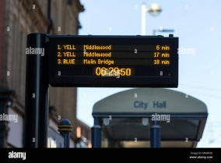 2. 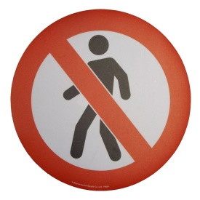

_____________________________ _____________________

4. 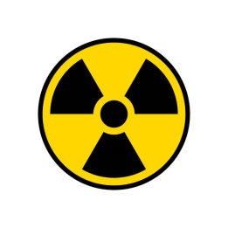 3. 
________________________ ______________________

5. 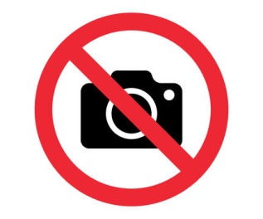
______________________
ANSWER KEY
Question A: Fill in the blanks.
- The subtract tool removes the overlaying shape from the parent shape.
- The unite tool adds/merges the selected shapes to create a single shape.
- Holding the shift key allows us to select multiple shapes
- The size, position and orientation (angle of rotation) can be set in the dimension parameters of the properties panel.
- The dimensions of an A4 size paper are 210mm * 297mm
- The subtract option is used to remove the overlaying shape.
- Text tool allows us to set parameters for text, changing its appearance.

Question B: State whether the statements are True/False.
- The unite tool removes the overlaying shape from the parent shape.
False
- The toolbar consists of tools that are used to create an artwork.
True
- We hold the shift key to select multiple shapes.
True
- The page panel does not display pages available in the document and allows us to set page properties.
False
- The shadow property casts a shadow of the object or shape.
True
Question C: Identify the meaning of the following signs

-  2. 

Stop Sign _ Traffic light

4.  3. 
Radiation sign _ CCTV Camera

5. 
No Camera

